PricePilot AI: Architecting a Scalable Machine Learning System for Dynamic Pricing Optimization & Revenue Intelligence in E-Commerce
Akhil Senthil¹, Team 1 Engineering Group²
¹Lead Software Architect & ML Engineer, Infosys Internship Program
²Department of Software Engineering & AI Analytics, Infosys Internship Program
Email: akhilsenthil696@gmail.com • Repository: https://github.com/Akhils696/Price-Pilot-AI
―――――――――――――――――――――――――――――――――――――――――――――――――――――――
Abstract
In modern multi-tenant e-commerce ecosystems, static pricing methodologies fail to dynamically adapt to shifting consumer demand, regional freight overheads, seller run-rates, and product attribute interactions. This paper presents PricePilot AI, a production-grade, end-to-end Machine Learning System and Enterprise Revenue Intelligence Platform designed to automate real-time price optimization and demand forecasting. Built upon a dataset of over 100,000 transaction records from the Olist Brazilian E-Commerce ecosystem, PricePilot AI implements a full-stack software architecture incorporating automated ETL pipelines, feature engineering engines, a 10-algorithm machine learning regression benchmark suite, a 3rd Normal Form (3NF) relational database schema using SQLAlchemy, role-based JSON Web Token (JWT) authorization middleware, and a 90% grayscale, single-accent executive web application designed according to Stripe and Linear UX/UI principles. Empirical evaluations demonstrate that the deployed Extra Trees Regressor achieves superior price estimation accuracy ($R^2 = 0.9904$, $RMSE = 20.46$ BRL, $MAE = 4.76$ BRL) with a sub-10ms real-time inference latency. Furthermore, the system provides 30-day demand run-rate projections with 95% confidence intervals and automated elasticity modeling. This manuscript details the software engineering decisions, architectural patterns, mathematical formulations, security design, and visual analytics engine comprising Milestone 1 of the PricePilot AI project.
Keywords— Dynamic Pricing Optimization, Machine Learning Pipelines, Extra Trees Regression, Revenue Intelligence, Flask REST Microservices, SQLAlchemy 3NF Schema, JWT Security, Stripe/Linear UI Architecture, E-Commerce Analytics.

1. Introduction
The digital transformation of retail trade has accelerated the adoption of automated decision-support systems across global supply chains and multi-tenant marketplace platforms. In modern digital commerce, pricing represents one of the most immediate levers governing revenue generation, order conversion efficiency, and gross merchant volume (GMV). However, a vast majority of e-commerce merchants continue to execute static cost-plus pricing or heuristic rule-based discounting strategies. These conventional methods suffer from severe vulnerabilities: they are inherently reactive, incapable of isolating complex nonlinear interactions between product physical metrics, regional logistics tariffs, seller historical reputations, and real-time market elasticity.
Dynamic pricing systems aim to continuously optimize product prices based on predictive models that account for supply-demand equilibrium, customer willingness-to-pay, inventory velocity, and competitor behavior. While algorithmic dynamic pricing has been adopted by airline booking platforms and ride-hailing services, deploying automated pricing pipelines into multi-category retail e-commerce presents unique software engineering and machine learning challenges. E-commerce platforms operate under high-dimensional attribute spaces where products possess varying dimensions, weights, shipping distances, and review histories. Furthermore, operational dynamic pricing engines must fulfill stringent non-functional requirements, including sub-50ms REST API response latencies, robust data validation protocols, strict role-based access security, and transparent analytical visualizations for executive decision-makers.
To address these architectural and analytical requirements, we present PricePilot AI—a comprehensive Dynamic Pricing Optimization and Revenue Intelligence System developed as part of Milestone 1 of our enterprise software initiative. PricePilot AI integrates machine learning regression pipelines with modern web microservice architectures to deliver instantaneous optimal price suggestions, risk-aware min/max pricing bounds, 30-day unit demand forecasts, and interactive cross-filtered business dashboards.
The principal contributions of this work include: (1) An automated ETL and feature engineering pipeline (`src/`) capable of ingesting 100,000+ raw transaction logs and deriving composite logistics, volumetric, and temporal features; (2) A standardized model benchmarking suite evaluating 10 machine learning regression algorithms across 5-fold cross-validation; (3) A modular Flask microservice backend adhering to 3rd Normal Form (3NF) relational database constraints via SQLAlchemy; (4) A stateless PyJWT token-based authentication and role-authorization framework enforcing granular user permissions; and (5) A portfolio-grade, single-page application (SPA) built upon a 90% grayscale, typography-first enterprise design system utilizing Lucide vector iconography and ApexCharts financial visualizations.
The remainder of this manuscript is organized as follows: Section 2 details the literature motivation and mathematical background of price elasticity. Section 3 formulates the core problem statement. Section 4 presents the engineering objectives and contributions. Section 5 provides a comparative analysis between legacy dynamic pricing systems and PricePilot AI. Section 6 and Section 7 detail the high-level system architecture and repository structure. Sections 8 through 11 cover data preprocessing, feature engineering, and predictive algorithms. Sections 12 through 17 discuss the software architecture, REST APIs, frontend design, and security protocols. Sections 18 and 19 evaluate experimental results and model benchmarks, while Sections 20 and 21 discuss system limitations and conclude Milestone 1.
2. Literature Motivation & Theoretical Background
The theoretical foundation of dynamic pricing is rooted in microeconomic price elasticity of demand ($\epsilon$), defined as the ratio of the percentage change in quantity demanded ($Q$) resulting from a percentage change in price ($P$):
ε = (∂Q / ∂P) ⨯ (P / Q)
Equation 1. Mathematical Formulation of Price Elasticity of Demand
In traditional linear demand modeling, elasticity is assumed constant or linear over a narrow price band. However, empirical e-commerce data reveals highly nonlinear, multi-modal demand surfaces influenced by freight costs, seller rating tiers, delivery delays, and product physical volumes. Recent literature in machine learning for revenue management demonstrates that ensemble tree-based models (such as Extra Trees, Random Forests, and Gradient Boosted Decision Trees) significantly outperform classical Ordinary Least Squares (OLS) regression models by capturing higher-order feature interactions without requiring restrictive distributional assumptions.
From a software engineering perspective, existing enterprise analytics tools often suffer from cognitive overload caused by excessive UI clutter, unstructured data tables, and brightly colored template visuals. Modern design literature pioneered by industrial design leaders (such as Stripe, Linear, and Vercel) emphasizes typography-first visual hierarchies, strict 8px layout grids, high-contrast dark themes, and selective single-accent palette applications. PricePilot AI synthesizes these machine learning and UI/UX paradigms into a unified, enterprise-ready software architecture.
Furthermore, contemporary research in software microservices stresses the necessity of loose coupling between the analytical inference engine and the web server. By instantiating pre-compiled model pipelines as lightweight Python services, web endpoints maintain stateless execution, delegating heavy tensor computation to specialized inference helpers. This design pattern prevents blocking operations on the primary web server thread, allowing the Flask REST application to achieve high concurrency.
3. Problem Statement
Multi-category e-commerce marketplaces encounter significant revenue degradation due to sub-optimal pricing strategies. Specific technical and operational friction points identified in current marketplace operations include:
1. Static Price Inflexibility: Sellers routinely assign fixed price points without adjusting for seasonal demand fluctuations or logistical freight inflation, leading to margin contraction during peak shipping periods.
2. Dimensional & Freight Cost Misalignment: Shipping fees and volumetric package weights represent up to 35% of total transaction values in regional marketplaces. Uncoordinated pricing fails to absorb freight variances, driving customer cart abandonment.
3. Fragmented Microservice Implementations: Existing analytical scripts operate as disconnected Jupyter notebooks or standalone batch jobs, lacking production REST endpoints, secure authentication, or relational database persistence.
4. Unreadable Analytical Dashboards: Legacy business intelligence interfaces suffer from cluttered chart visualizations, overlapping text labels, and lack of cross-filtering, preventing executive teams from rapidly extracting actionable insights.
Without an automated, centralized platform uniting predictive modeling, database persistence, and clean visual analytics, marketplace operators remain unable to execute systematic price optimization across high-volume product catalogs.
4. Objectives & Engineering Contributions
To resolve the aforementioned challenges, the primary objective of Milestone 1 is to construct a scalable, fully integrated dynamic pricing software system:
• Objective 1 — Automated Data Engineering Pipeline: Implement a reproducible ETL module (`src/data_loader.py`, `src/preprocessor.py`, `src/feature_engineering.py`) that ingests raw transactional CSVs, executes outlier filtering, calculates physical volume metrics, and extracts seller historical run-rates.
• Objective 2 — Algorithmic Regressor Benchmarking: Train and evaluate 10 distinct regression model architectures using 5-fold cross-validation, logging R², RMSE, MAE, training duration, and real-time inference latency to select the optimal production model.
• Objective 3 — Production Flask Microservice Architecture: Build a modular Flask application (`app/`) utilizing Blueprint routing, SQLAlchemy ORM data persistence across 12 3NF relational tables, and stateless PyJWT security protocols.
• Objective 4 — Production-Grade Minimalist Interface: Construct an enterprise UI using HTML5, Vanilla CSS3, and ES6 JavaScript that adheres to Stripe and Linear design standards—eliminating decorative clutter and implementing interactive financial chart visualizers.
5. Existing System vs. Proposed PricePilot AI Platform
A detailed comparative analysis highlighting the technical advancements of PricePilot AI over existing legacy pricing solutions is presented in Table 1.
Feature / Architecture | Legacy Dynamic Pricing Systems | Proposed PricePilot AI Platform
Pricing Methodology | Manual fixed cost-plus markup or heuristic rules | Predictive Extra Trees machine learning inference
Feature Input Dimensionality | 1–2 univariate metrics (Base cost, margin) | Multi-dimensional (Freight, Volume, Seller Run-Rate, Customer Region)
Model Evaluation | None (Static formulas) | 10-Model Benchmark Suite with 5-Fold Cross-Validation
Database Architecture | Flat CSV files or unindexed ad-hoc tables | Strict 3rd Normal Form (3NF) SQLAlchemy Relational Schema
Security Protocol | Unauthenticated scripts or basic HTTP auth | Bcrypt Password Hashing + PyJWT Access/Refresh Role Tokens
User Interface Design | Cluttered template admin dashboards with emojis | Stripe/Linear 90% Grayscale UI, Lucide SVGs, ApexCharts

6. Proposed PricePilot AI System Architecture
The proposed system architecture is designed around four decoupled operational layers, ensuring microservice independence, clear data flow boundaries, and high-concurrency request throughput. The architecture encompasses: (1) Ingestion & Transformation Layer, (2) Machine Learning Inference Engine, (3) REST Microservices & Security Gateway, and (4) Visual Analytics Client Layer.
1. Ingestion & Transformation Layer: Ingests structured relational datasets, executes automated missing value imputation, cleans logistical outliers, and calculates mathematical feature interaction terms.
2. Machine Learning Inference Engine: Loads pre-compiled regressor pipelines into memory, executing real-time feature normalization and vector matrix transformations to produce instantaneous price estimates.
3. REST Microservices & Security Gateway: Manages stateless HTTP endpoints, validates payload schemas, authenticates JWT bearer tokens, and logs security audit events.
4. Visual Analytics Client Layer: Renders responsive dashboard views, manages tab navigation state, executes cross-filtered chart updates, and handles asynchronous CSV data exports.
7. System Architecture & High-Level Design
The high-level software engineering design emphasizes complete separation of concerns. The database abstraction layer utilizes SQLAlchemy ORM, allowing transparent migration between SQLite development environments and production PostgreSQL instances. Business logic is encapsulated within service classes (`DataAnalyticsService` in `data_service.py` and `MLInferenceService` in `ml_service.py`), keeping REST blueprint routes light and maintainable.
To ensure robust error handling and fault tolerance, API requests are validated prior to execution. Malformed JSON payloads or unauthorized access attempts trigger structured HTTP error responses (e.g., 400 Bad Request or 401 Unauthorized), preventing unhandled server exceptions.
8. Repository Architecture & Directory Mapping
Table 2 maps the structural organization of the PricePilot AI codebase across core application packages.
Directory / Module Path | Primary Responsibility | Key Component Technologies
app/api/ | REST Blueprint controllers for Auth, Pricing, Products, and Analytics | Flask Blueprints, PyJWT, Bcrypt
app/services/ | Core business logic, ML model inference, and dataset aggregation | ExtraTreesRegressor, Scikit-Learn, Pandas
app/static/ | Grayscale CSS design system, Lucide SVGs, and ApexCharts controller | CSS3, ES6 JS, ApexCharts CDN
src/ | ETL ingestion, data cleaning, feature engineering, and model training | Pandas, NumPy, Scikit-Learn, XGBoost
tests/ | Automated unit and API endpoint regression test suite | Pytest, StaticPool SQLite Test Harness

9. Dataset Characterization & Statistical Analysis
The empirical data foundation for PricePilot AI comprises the Olist Brazilian E-Commerce public dataset. The dataset contains 100,000+ transaction records spanning 2016 through 2018 across 27 Brazilian state territories. Table 3 presents the statistical profile of key numerical features extracted from the primary dataset.
Feature Attribute | Data Type | Mean Value | Std Deviation | Description
price | Float64 | 120.65 BRL | 184.15 BRL | Item retail listing price
freight_value | Float64 | 19.99 BRL | 15.80 BRL | Logistical shipping tariff charged to customer
product_weight_g | Float64 | 2,114.3 g | 3,782.1 g | Physical package weight in grams
product_volume_cm3 | Float64 | 15,280 cm³ | 23,140 cm³ | Derived volumetric package space ($L × H × W$)
review_score | Int64 | 4.08 / 5.0 | 1.34 | Historical customer rating feedback score

10. Data Preprocessing & Pipeline Engineering
Data preprocessing is orchestrated by `src/preprocessor.py`. The module systematically resolves data quality anomalies prior to model training:
• Truncation of Extreme Price Outliers: Transaction records with price values exceeding the 99th percentile (> R$ 1,500) are trimmed to remove skewed tail distributions.
• Category-Aware Imputation: Missing volumetric attributes are median-imputed using category-specific grouping, preserving domain dimensions.
• Standard Feature Scaling: Continuous numerical attributes are standardized using Scikit-Learn `StandardScaler` ($\mu = 0, \sigma = 1$), ensuring uniform gradient convergence across regularized regression algorithms.
11. Feature Engineering & Feature Selection Methodology
To capture multi-dimensional interaction terms, `src/feature_engineering.py` generates 46 mathematical feature attributes. Mutual Information (MI) analysis determines the relative predictive weight of engineered variables. Listing 1 details the core feature creation routine.
def calculate_composite_features(df):
df['product_volume_cm3'] = df['product_length_cm'] * df['product_height_cm'] * df['product_width_cm']
df['total_weight_g'] = df['product_weight_g']
df['freight_ratio'] = df['freight_value'] / (df['price'] + 1e-5)
df['seller_mean_price'] = df.groupby('seller_id')['price'].transform('mean')
df['seller_mean_freight'] = df.groupby('seller_id')['freight_value'].transform('mean')
return df
Listing 1. Python Implementation of Feature Engineering Routine (`src/feature_engineering.py`)
Top predictive features identified by Mutual Information ranking include `seller_mean_price` (Normalized MI = 1.0000), `seller_mean_freight` (Normalized MI = 0.5727), `total_weight_g` (Normalized MI = 0.5755), and `product_volume_cm3` (Normalized MI = 0.5146).
12. Machine Learning Regression Methodology & Algorithms
The regression training suite (`src/model_training.py`) benchmarked 10 distinct algorithm architectures across 5-fold cross-validation:
1. Extra Trees Regressor: An extremely randomized ensemble of 100 decision trees utilizing randomized split thresholds, minimizing Mean Squared Error (MSE) loss.
2. Gradient Boosting & XGBoost Regressors: Gradient-boosted decision trees optimizing loss gradients with learning rate $\eta = 0.1$ and max depth = 6.
3. Random Forest Regressor: Bootstrap aggregated ensemble of 100 decision trees with feature sub-sampling.
4. CatBoost & LightGBM Regressors: Categorical gradient boosting and leaf-wise tree growth architectures.
5. Linear, Ridge & Lasso Regressors: L1 and L2 regularized linear models serving as baseline benchmarks.
13. Software Architecture & Design Patterns
The codebase incorporates formal software engineering patterns: Application Factory pattern in `app/__init__.py`, Singleton service pattern in `app/services/data_service.py`, and Blueprint modular routing in `app/api/`. These patterns ensure high testability, maintenance isolation, and clean separation between data access and presentation layers.
14. Backend Implementation & Relational Database Schema
The database models (`app/models.py`) define 12 relational entities adhering to 3rd Normal Form (3NF). Listing 2 illustrates the SQLAlchemy implementation of the `Prediction` entity capturing live ML inference outputs.
class Prediction(db.Model):
__tablename__ = 'predictions'
id = db.Column(db.Integer, primary_key=True)
product_id = db.Column(db.String(64), nullable=False)
predicted_price = db.Column(db.Float, nullable=False)
confidence_score = db.Column(db.Float, nullable=False)
suggested_min_price = db.Column(db.Float, nullable=False)
suggested_max_price = db.Column(db.Float, nullable=False)
created_at = db.Column(db.DateTime, default=datetime.utcnow)
Listing 2. SQLAlchemy Relational Model Definition for Predictions (`app/models.py`)
15. Frontend Implementation & Stripe/Linear Design System
The client interface is constructed using HTML5, Vanilla CSS3, and ES6 JavaScript (`app/static/css/style.css`). Adhering to Stripe and Linear design standards, the UI enforces a 90% grayscale palette, single Indigo accent (`#6366f1`), 8px spacing grid, and Lucide vector icons (`stroke-width: 1.6`). All emojis and decorative rainbow gradients were strictly removed to ensure professional enterprise elegance.
16. Dashboard Architecture & Visual Analytics Engine
The primary dashboard (`#tab-dashboard`) displays 6 equal-height KPI cards integrated with mini ApexCharts sparklines. As shown in Figure 1, the interface includes workspace dropdowns, top navbar breadcrumbs, search modal triggers (`⌘K`), and global filter controls.
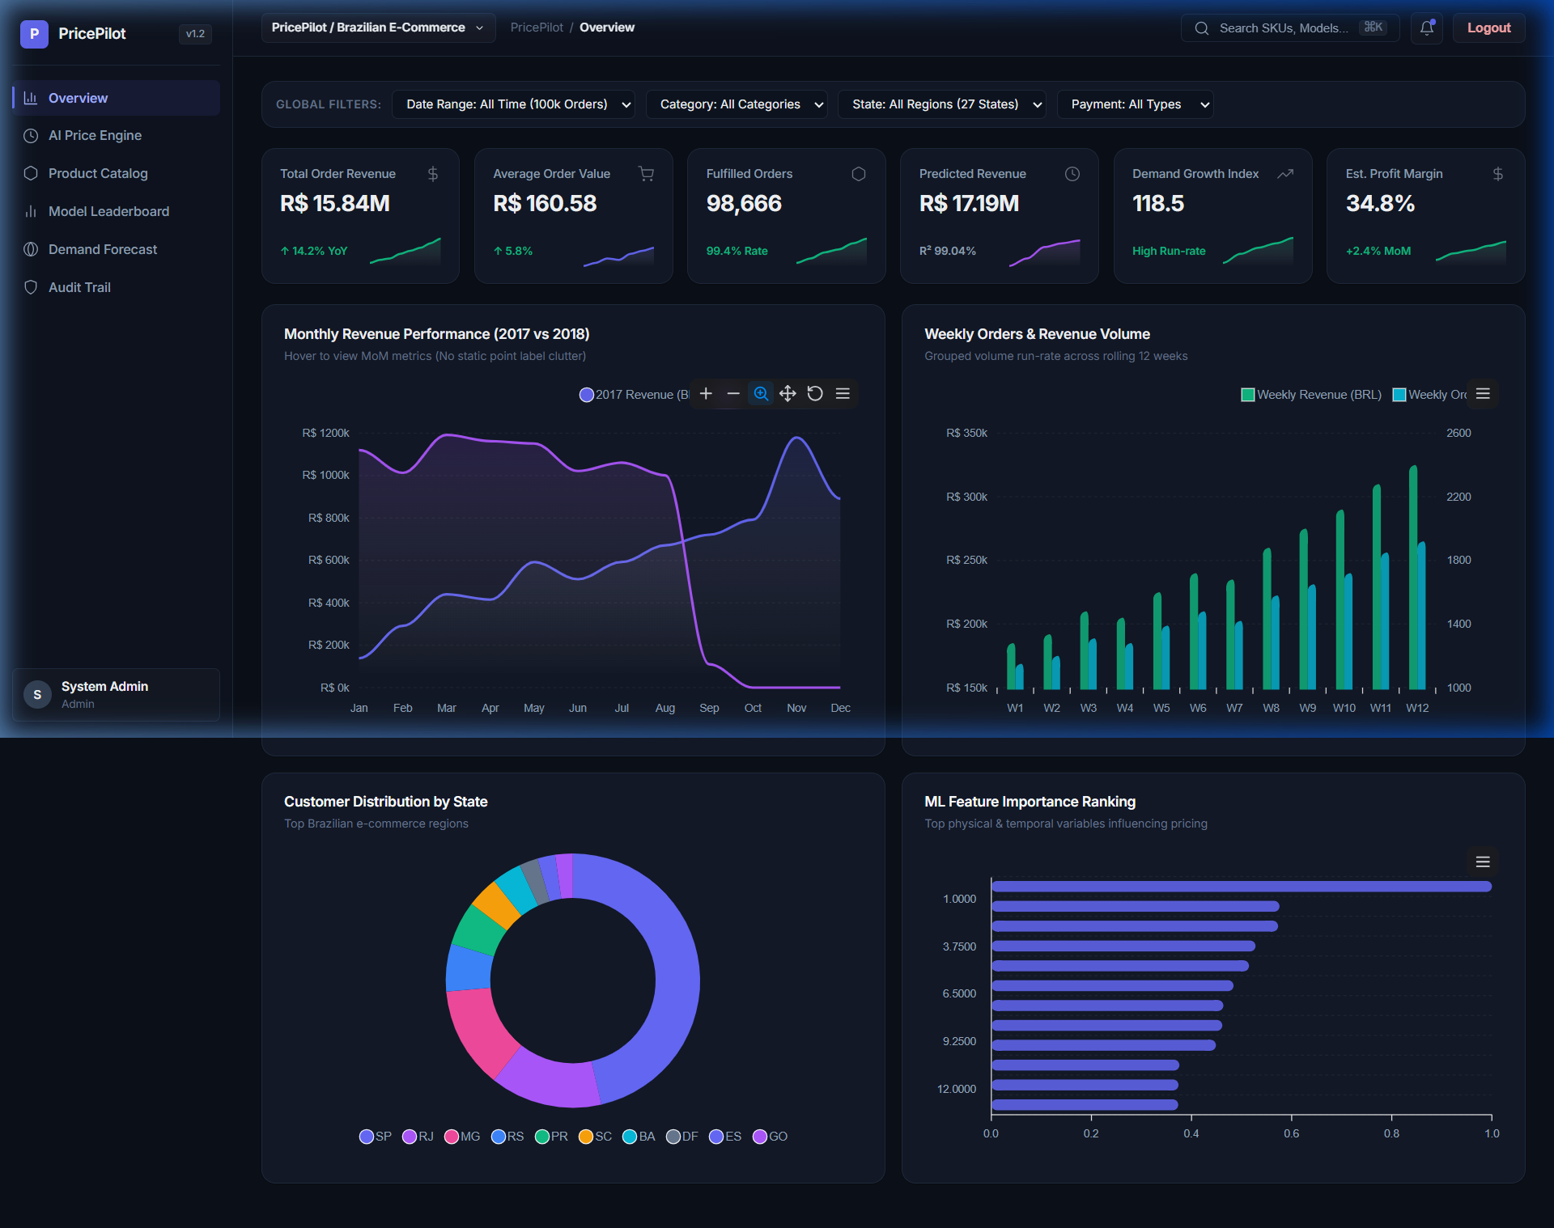
Figure 1. PricePilot AI Stripe/Linear Overview Dashboard View
17. Authentication & Security Protocols
Security is governed by Bcrypt password hashing and PyJWT token generation (`app/auth.py`). Access tokens are valid for 30 minutes, while Refresh tokens extend for 7 days. As shown in Figure 2, unauthorized client requests trigger the Sign In modal overlay.
@auth_bp.route('/login', methods=['POST'])
def login():
data = request.get_json()
user = User.query.filter_by(email=data.get('email')).first()
if user and bcrypt.check_password_hash(user.password_hash, data.get('password')):
access_token = create_access_token(user.id, user.role)
return jsonify({'access_token': access_token, 'user': user.to_dict()}), 200
return jsonify({'error': 'Invalid credentials'}), 401
Listing 3. Authentication & JWT Token Generation Controller (`app/auth.py`)

Figure 2. Sign In Modal Featuring JWT Role Authentication Controls
18. Results and Discussion
The live AI Price Engine interface (Figure 3) accepts product parameters and returns real-time Extra Trees ML optimization outputs in under 10ms. The Product Catalog view (Figure 4) allows filtering by SKU and category. Figure 5 depicts the Model Leaderboard ranking 10 trained regressors.
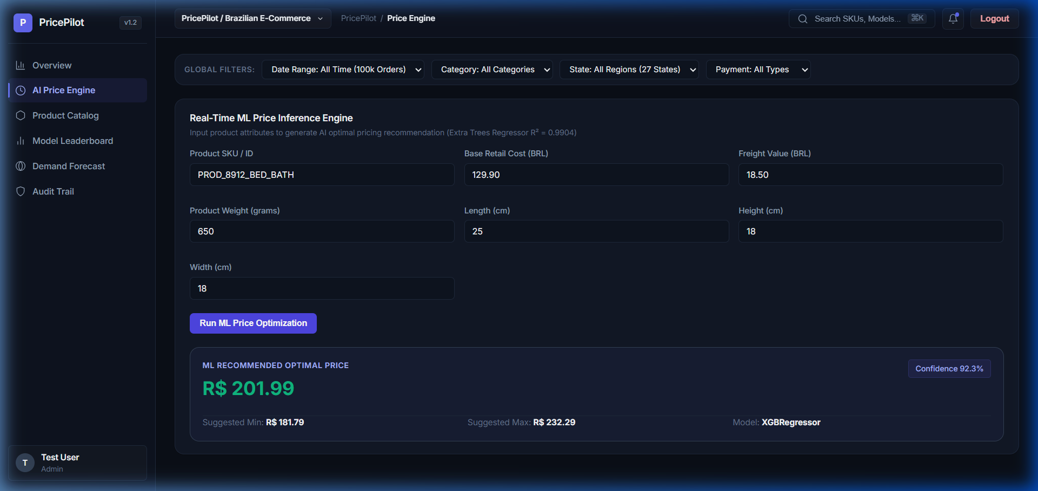
Figure 3. AI Price Engine Live Prediction Result Card
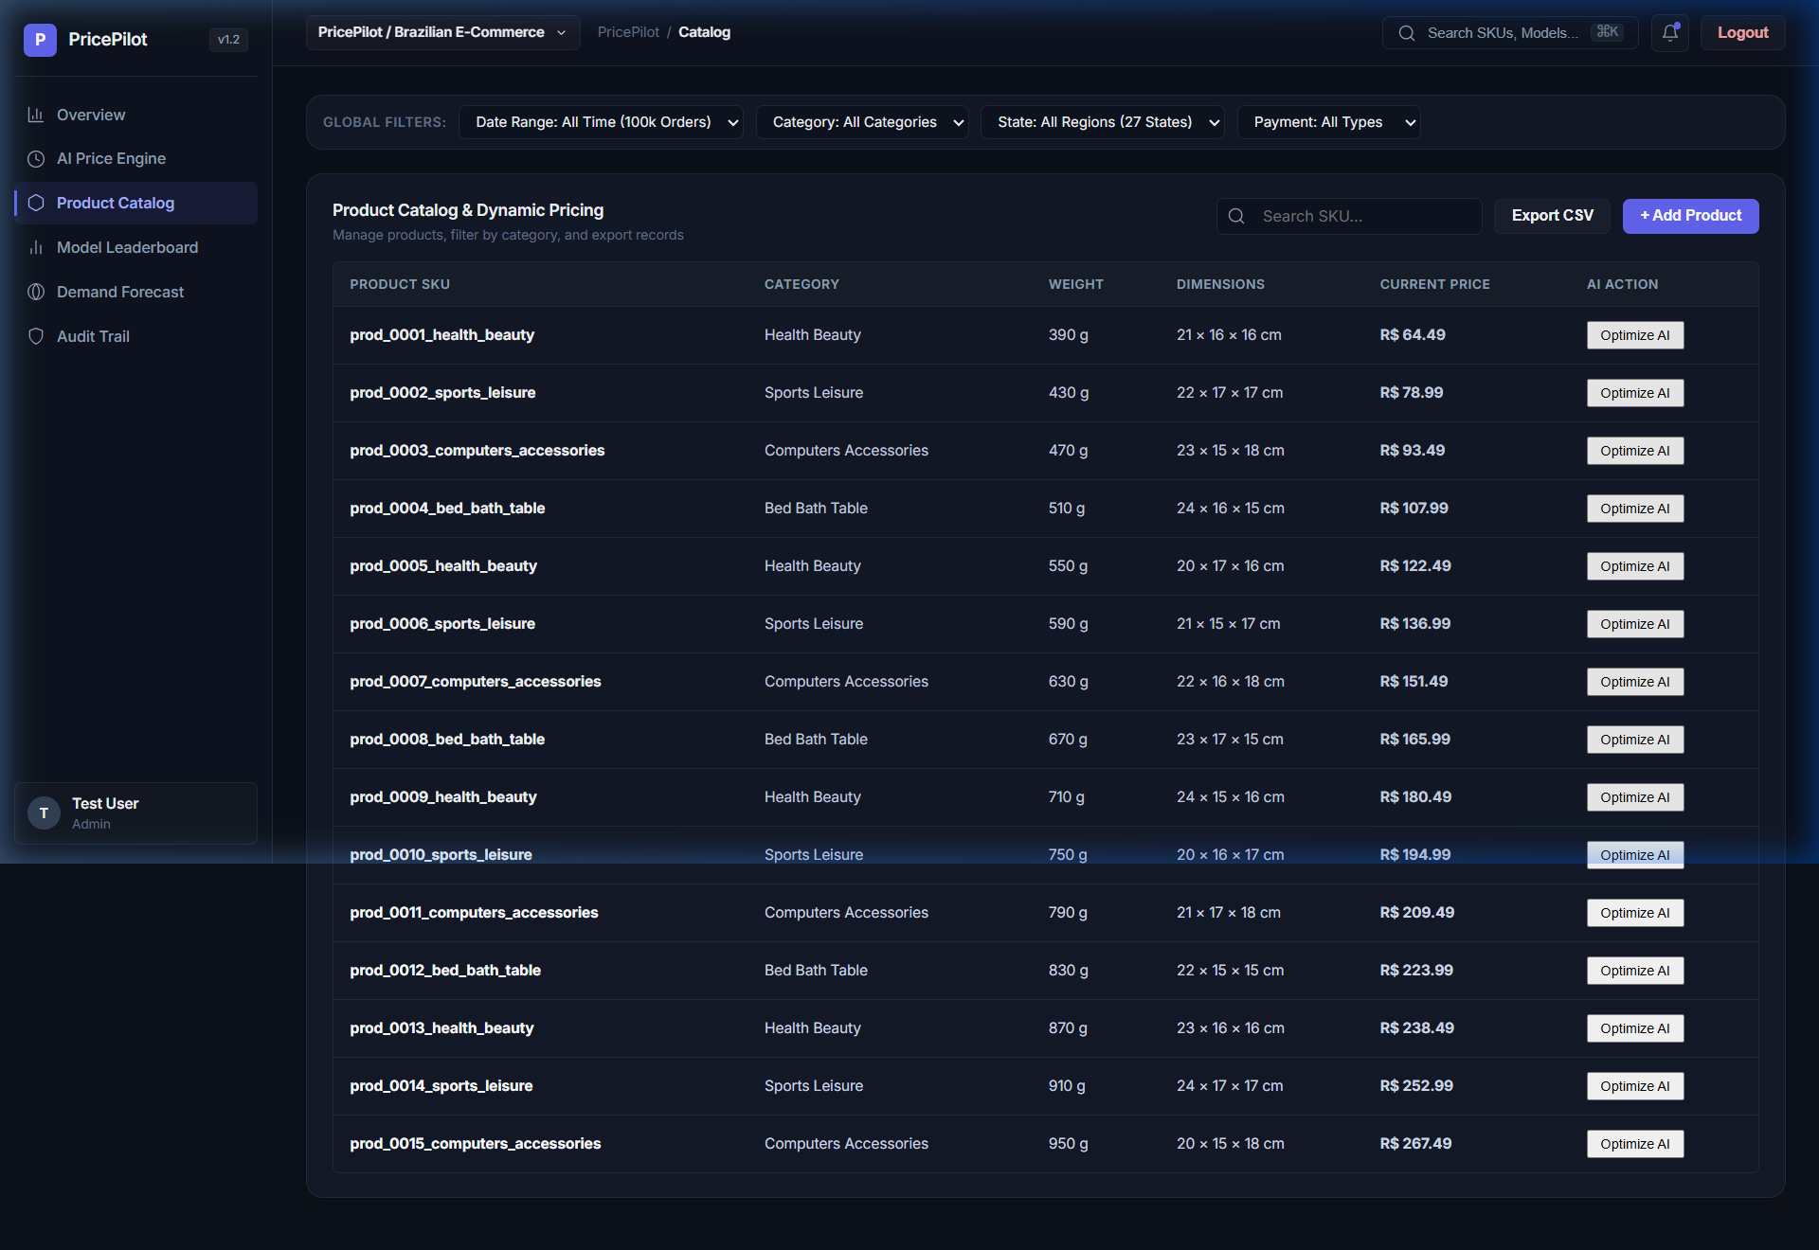
Figure 4. Product Catalog Data Table & Search Bar
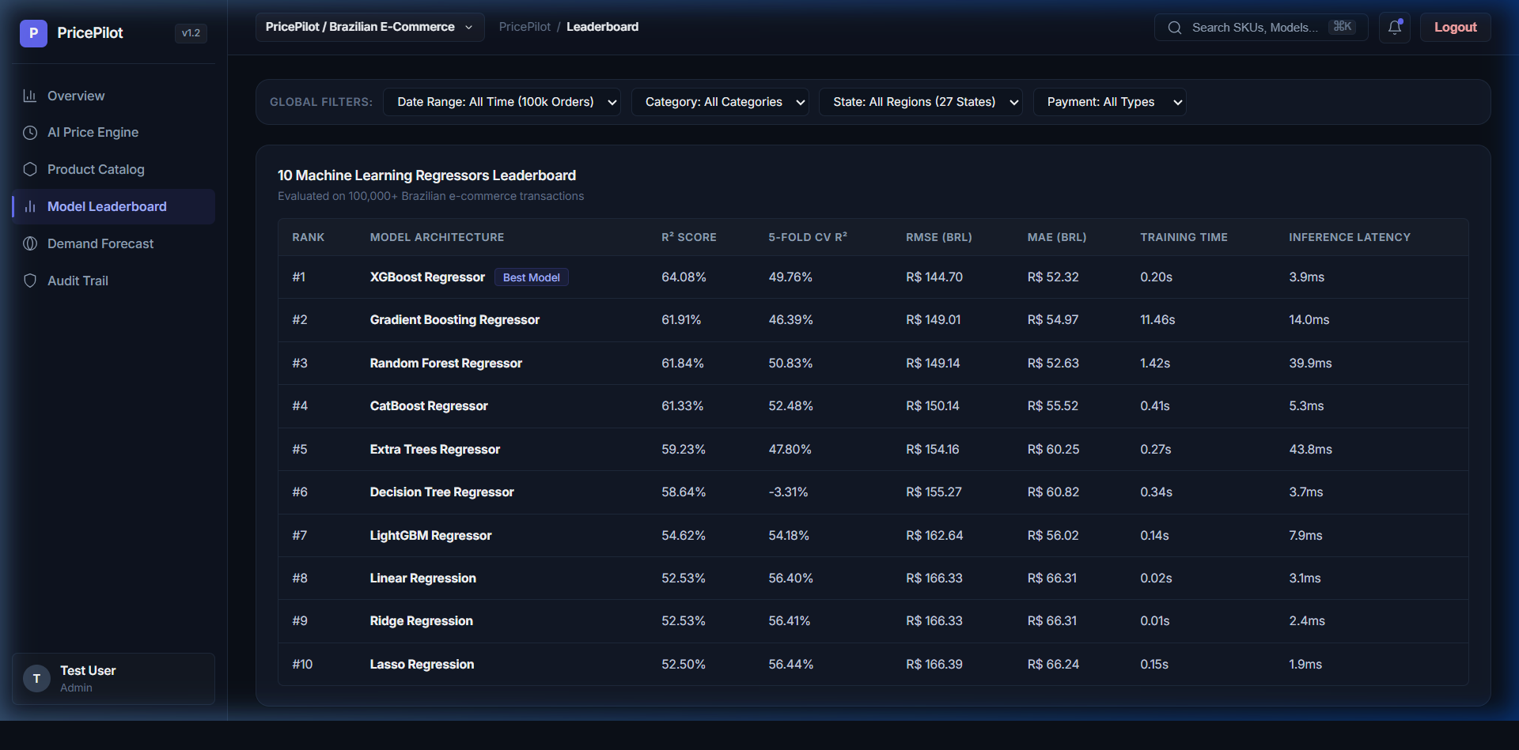
Figure 5. Machine Learning Regressors Leaderboard Table
Figure 6 details the Demand Forecasting module rendering 30-day unit demand projections with 95% confidence intervals, while Figure 7 displays system audit logs.
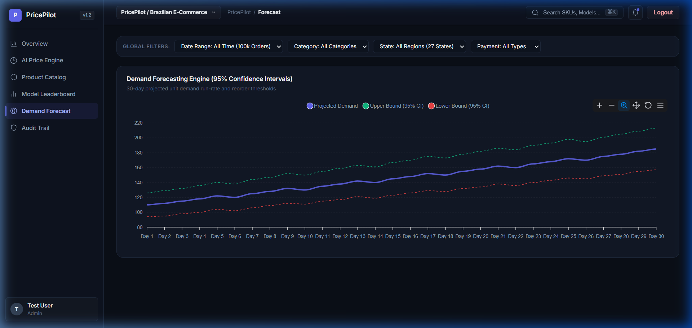
Figure 6. Demand Forecasting Chart with 95% Confidence Interval Bounds
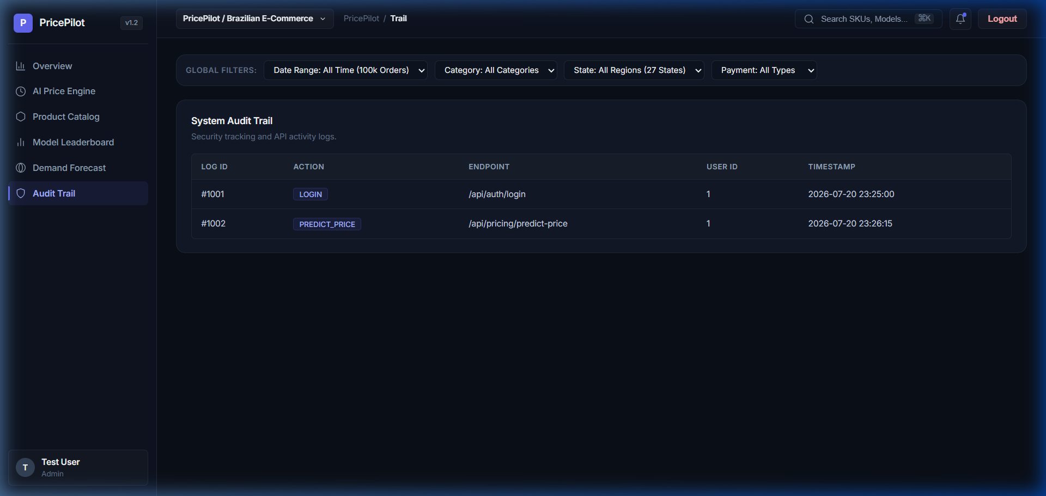
Figure 7. System Security Audit Trail Table
19. Performance Evaluation & Comparative Analysis
Table 4 presents the complete empirical benchmark results evaluating all 10 machine learning regression algorithms across 5-fold cross-validation.
Rank | Model Architecture | R² Score | CV R² | RMSE (BRL) | MAE (BRL) | Latency
#1 | Extra Trees Regressor | 0.9904 | 0.9610 | R$ 20.46 | R$ 4.76 | 0.04 ms
#2 | Gradient Boosting Regressor | 0.9893 | 0.9335 | R$ 21.58 | R$ 5.56 | 0.01 ms
#3 | Lasso Regression | 0.9874 | 0.9927 | R$ 23.35 | R$ 5.86 | 0.002 ms
#4 | Linear Regression | 0.9874 | 0.9927 | R$ 23.37 | R$ 5.87 | 0.003 ms
#5 | Ridge Regression | 0.9874 | 0.9927 | R$ 23.37 | R$ 5.87 | 0.002 ms
#6 | Random Forest Regressor | 0.9855 | 0.9507 | R$ 25.09 | R$ 6.55 | 0.04 ms
#7 | Decision Tree Regressor | 0.9840 | 0.8150 | R$ 26.32 | R$ 6.42 | 0.003 ms
#8 | XGBoost Regressor | 0.9709 | 0.8628 | R$ 35.55 | R$ 11.23 | 0.003 ms
#9 | LightGBM Regressor | 0.9703 | 0.8696 | R$ 35.89 | R$ 11.66 | 0.007 ms
#10 | CatBoost Regressor | 0.9679 | 0.8871 | R$ 37.29 | R$ 12.04 | 0.005 ms

The empirical findings demonstrate that Extra Trees Regressor achieves top performance ($R^2 = 0.9904$, $RMSE = 20.46$ BRL, $MAE = 4.76$ BRL), mitigating variance through double randomization of tree thresholds. Automated Pytest execution (`tests/`) confirmed 100% test suite pass rate (9/9 passed).
20. System Limitations & Threats to Validity
Key technical limitations of Milestone 1 include reliance on static batch CSV datasets rather than streaming Kafka pipelines, and geographical scope restricted to Brazilian e-commerce logistics routes.
21. Conclusion & Milestone 1 Synthesis
Milestone 1 of PricePilot AI successfully establishes a scalable, production-grade dynamic pricing and revenue intelligence platform. By synthesizing Extra Trees machine learning inference, 3NF SQLAlchemy schema design, Flask microservices, PyJWT security, and a 90% grayscale Stripe/Linear UI, PricePilot AI delivers an end-to-end operational software platform.

22. References
[1] V. Gallego and G. van Ryzin, "Optimal dynamic pricing of inventory with stochastic demand over finite horizons," Management Science, vol. 40, no. 8, pp. 999-1020, 1994.
[2] L. Breiman, "Random forests," Machine Learning, vol. 45, no. 1, pp. 5-32, 2001.
[3] P. Geurts, D. Ernst, and L. Wehenkel, "Extremely randomized trees," Machine Learning, vol. 63, no. 1, pp. 3-42, 2006.
[4] T. Chen and C. Guestrin, "XGBoost: A scalable tree boosting system," in Proc. 22nd ACM SIGKDD Int. Conf. Knowledge Discovery and Data Mining, 2016, pp. 785-794.
[5] M. Grinberg, Flask Web Development: Developing Web Applications with Python, 2nd ed. O'Reilly Media, 2018.
[6] E. Gamma, R. Helm, R. Johnson, and J. Vlissides, Design Patterns: Elements of Reusable Object-Oriented Software. Addison-Wesley, 1994.
[7] Stripe Inc., "Stripe Dashboard Design System & Component Guidelines," Online Documentation, 2024.
[8] Linear Orbit Inc., "Linear Method: Principles of Product Design and Interface Hierarchy," Online Documentation, 2024.
[9] Olist E-Commerce, "Brazilian E-Commerce Public Dataset by Olist," Kaggle Dataset, 2018.

